ATOMIC ENERGY CENTRAL SCHOOL-5, MUMBAI
PORTFOLIO FOR CLASS X
Solve the questions given below as submit as a portfolio file. (Solve them in A4 sheets and file them together or staple them)
1. A sentiment analysis model was built to classify movie reviews as either. ‘Positive’ or ‘Negative’. The model was tested on a dataset of 500 reviews, resulting in the following confusion matrix :
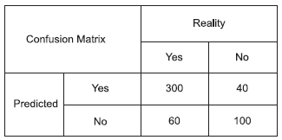
(a) How many total cases are True Positive in the above scenario?
(b) Calculate Precision, Recall and F1-Score.

2. A disease detection model gave the following confusion matrix results:
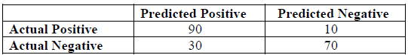
Questions:
a) Calculate Accuracy.
b) Calculate Precision, Recall and F1 score.

3. A spam detection model gave the following results:
True Positives (TP) = 70 , False Positives (FP) = 10
True Negatives (TN) = 50, False Negatives (FN) = 20
a) Calculate the Accuracy of the model.
b) Calculate the Precision and Recall (in percentage).
c) Based on the results, explain whether the model focuses more on precision or recall.

4. You have two documents :
Document 1 : Sheetal and Mitali are friends.
Document 2 : Mitali likes singing songs while Sheetal likes listening to music.
Through a step-by-step process, calculate TFIDF for the given corpus.

5. For the given sentences, create the BoW representation and then compute
TF–IDF values.
Document 1: Chatbots use Natural Language Processing.
Document 2: NLP helps chatbots understand human language.
Document 3: Artificial Intelligence powers chatbot conversations.
a) Prepare a BoW table showing word occurrences.
b) Calculate TF–IDF values for the words “chatbots” and “language.”
c) Explain in 2–3 lines how TF–IDF provides a more meaningful
representation than BoW.
___________

